DMX-512 Wireless Distribution
Gateway User Guide

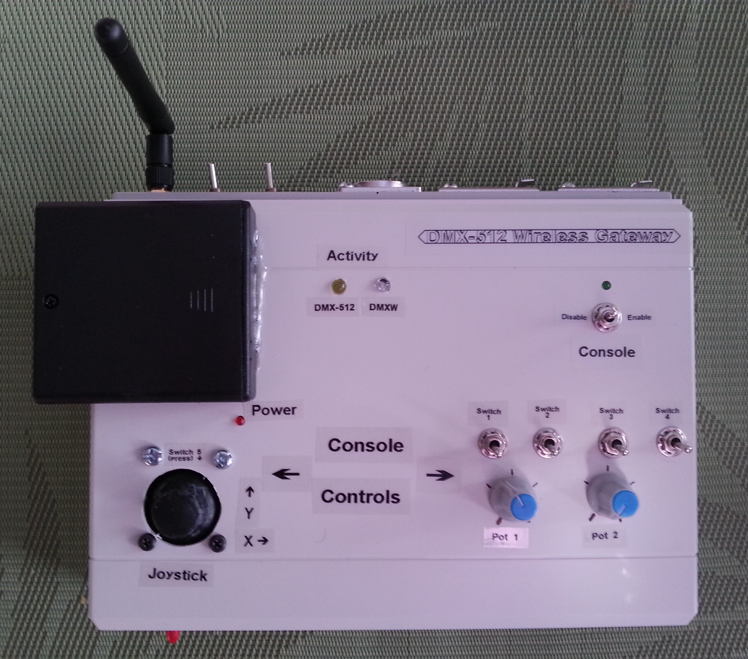

John van Schouwen
2014

Table of Contents
1 Introduction 5
1.1 Overview 5
1.2 Features 5
1.3 Gateway Layout 7
2 Connecting the DMXW Gateway 10
2.1 Connecting to a DMX-512 Bus 10
2.2 Connecting a Serial Terminal to the Configuration Port 11
2.2.1 Software Installation 11
2.2.2 Connecting the Configuration Terminal 11
3 Configuring the DMXW Gateway 15
3.1 Entering Configuration Terminal Commands 15
3.2 Disabling the Configuration Terminal 16
3.3 About DMX Distribution Modes 16
3.4 Mapping DMX-512 Channels to DMXW Channels 18
3.5 Mapping Console Controls to DMXW Channels 19
3.6 Saving and Clearing Configuration Data 20
3.7 Copying Channel Mappings from Gateway to Remote Node 21
3.8 Miscellaneous Commands 21
3.9 Firmware Developer Commands 22
4 Operating the DMXW Gateway 23
4.1 Setting Up 23
5 Configuring and Programming Remote DMXW Receiver Nodes 25
5.1 Powering a Remote DMXW Receiver Node 26
6 Upgrading the DMXW Gateway Firmware 27

Introduction

Overview
DMX-512 is an electrical and data communications standard commonly used to control stage lighting and effects. It defines up to 512 channels of data, each intended to control a lighting fixture or an aspect of a lighting fixture (e.g. lighting fixture rotation, and lighting element brightness).
The DMX Wireless Distribution Gateway (or DMXW Gateway) has the capability to redistribute DMX-512 lighting control channels to (usually battery-powered) wireless remote DMXW receiver nodes that are connected to lighting fixtures, motors, actuators, etc. The gateway extracts up to 48 selected channels from a wired DMX-512 bus and redistributes them to up to 48 output ports located at up to 19 uniquely numbered remote DMXW nodes,. Using a computer running Windows or Linux, the user can configure the DMX-512 channels to be redistributed. Various test functions are also available via this Config Port.
The gateway also houses Console Controls (switches, potentiometers, and a 2-axis joystick with push-button) that can be assigned to DMXW channels and can override the DMX-512 channels to which they are assigned.

Features
The following are the DMXW GW features:
- Wireless redistribution (using the DMXW protocol) of up to 48 configurable DMX-512 channels onto DMXW channels.
- Support for up to 19 uniquely numbered remote DMXW wireless receiver nodes
- remote nodes may be cloned
- 433 MHz radio with range > 150 metres for DMXW distribution.
- Capability for fully mobile, standalone, manual, wireless control of up to 9 remote devices connected to one or more remote DMXW receiver nodes.
- Configurable manual console controls that can be used to override up to 9 DMXW channels:
- 4 toggle switches for on/off control (DMX-512 values 0 (off) or 255 (on))
- 2 potentiometers for dimming control
- 1 two-axis, spring-loaded joystick for dimming control
- 1 momentary contact joystick push-button for on/off control
- Console Control enable/disable switch and status indicator
- USB Configuration Port
- 9600 baud, 8-bit data, no parity, 1 stop bit
- Configuration port enable/disable switch
- Dual power option:
- 4 x AA battery pack, or
- 6 – 12 V dc, 200 mA wall adaptor using a 1/8” headphone jack (negative tip)
- DMX-512 and DMXW activity indicators
- DMX-512 bus connectivity:
- 5-pin male, 5-pin female, and 3-pin female XLR connectors for connecting to a DMX-512 bus
- unused connectors can be used for relaying the bus to additional DMX-512 devices
- DMX-512 data line polarity reversal switch (reserves the signal polarities on XLR pins 2 and 3)
- DMX-512 termination resistor (120 Ω) selector switch
- Programming Port for upgrading the gateway's firmware
- USB-to-FTDI adaptor required
- Gateway is programmed from the freely available Arduino programming environment
- Operating Mode switch selects either normal operating mode or firmware programming mode
- Freely available, open source software and development environment
- The gateway's firmware is open source Arduino code
- DMXW remote wireless receiver nodes use Arduino boards and RFM69W (433 MHz) radio modules programmed with open source Arduino code
- Assembled Arduino/radio boards (Moteino boards) can be purchased at
http://www.lowpowerlab.com/shop
for about $21 USD (as of March, 2014)
- Nodes will require some knowledge of electronics and construction of external circuitry in order to interface the board with output devices (such as LED’s, incandescent lamps, motors, actuators, etc.)

Gateway Layout
Figure 1 Shows the main operating controls: the console controls and DMX activity indicators.
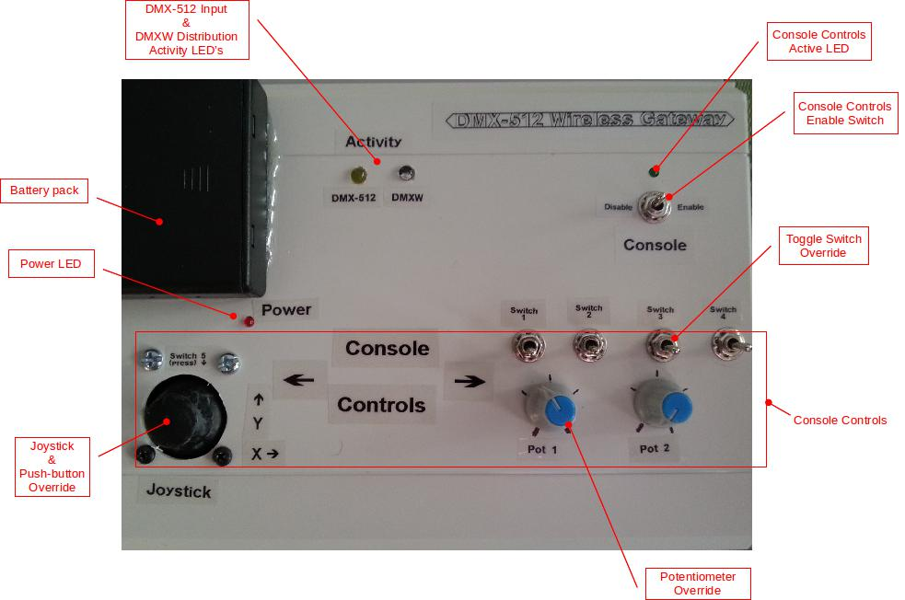Figure 1: Top View

Figure 2 Shows the DMX-512 bus connectors and controls and the antenna located at the rear of the DMXW Gateway.
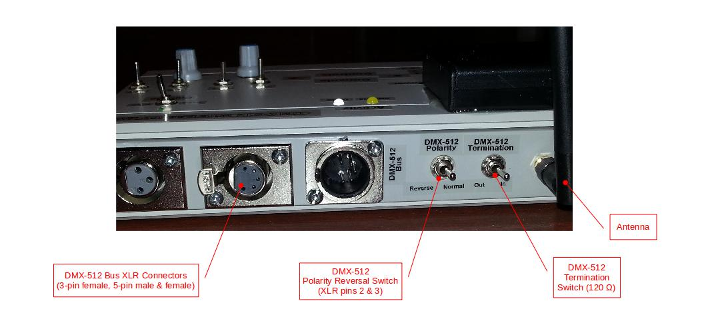Figure 2: Rear View

Figure 3 Shows the DMXW Gateway's front panel containing the power switch and the configuration and programming connectors and controls.
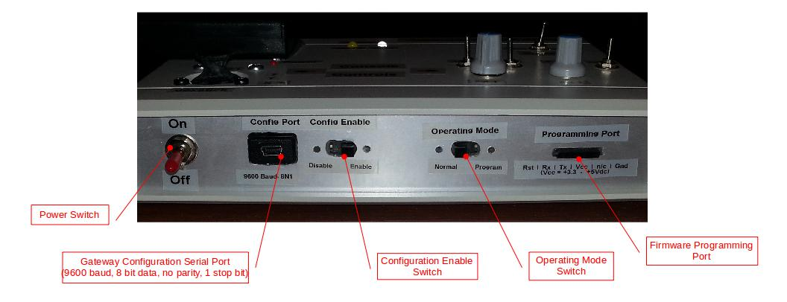Figure 3: Front View

Figure 4 Shows the power sources located at the left side of the DMXW Gateway.
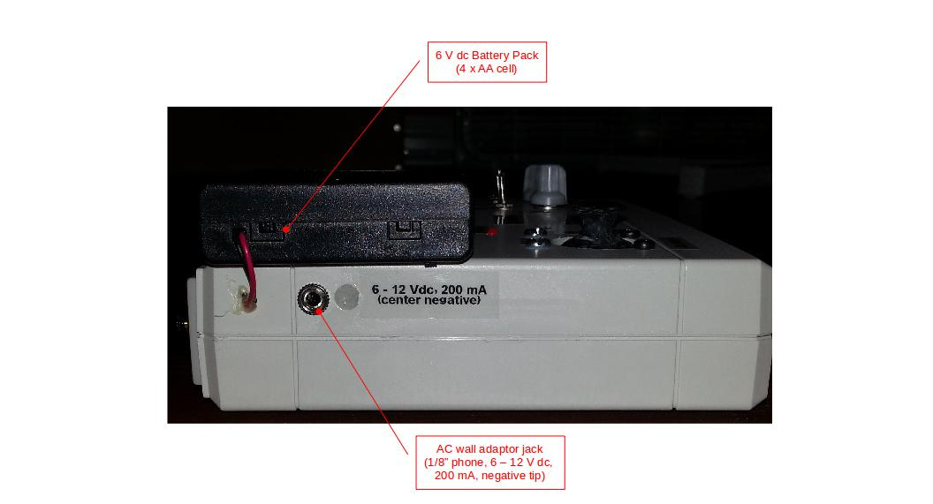Figure 4: Left Side View

Connecting the DMXW Gateway

Connecting to a DMX-512 Bus
The DMXW Gateway can operate as either a standalone controller (using only the console controls) or connected to a DMX-512 bus for redistribution of selected channels using the DMXW wireless protocol. Referring to Figure 5, when connecting the DMXW Gateway to a DMX-512 bus, it may be connected as either an intermediate node (as shown in the figure) or as a terminating node (e.g. if DMX-512 Device #3 was disconnected).
It is often necessary for the last node on the bus to add a 120 Ω terminating resistor across the two DMX-512 data lines. If this is necessary set the DMX-512 Termination switch to the “In” position; otherwise set it to the “Out” position.
With the DMX-512 Polarity switch set to the “Normal” position, connect the DMXW Gateway to the DMX-512 bus and turn on power to the gateway. Ensure that the Power LED is lit. Make sure that the lighting desk is running DMX-512 data thru the bus. The DMX-512 Activity LED should pulsate to indicate that it is correctly receiving DMX-512 data. If the LED doesn't glow, toggle the DMX-512 Polarity switch to the “Reverse” position. If the DMX-512 Activity LED still doesn't glow, check the DMX-512 bus connections and cables, and double check that data is being transmitted by the lighting desk.
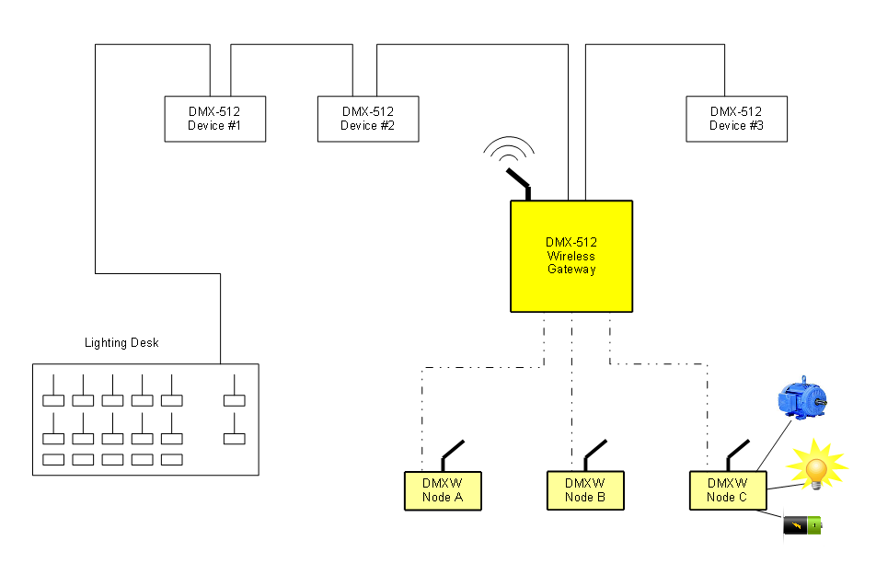Figure 5: DMX-512 Network Connectivity

Connecting a Serial Terminal to the Configuration Port

Software Installation
Once DMX-512 activity has been confirmed, you can configure the DMX-512 channels that you wish to redistribute wirelessly. The gateway uses a CP2102 USB-to-UART (USB-to-Serial) device that provides a virtual serial COM port thru which the gateway can be configured. Before connecting a configuration terminal to the DMXW Gateway:
- Install the CP2102 driver (both Windows and Linux versions are freely available on the Web).
- If terminal emulator software isn't already installed on the computer, install PuTTY. (This is freely available on the Web.) PuTTY is the recommended terminal emulator.
You are now ready to connect a configuration terminal to the DMXW Gateway (see section 2.2.2 Connecting the Configuration Terminal). Once connected, you can proceed with configuring the gateway (see section 3 Configuring the DMXW Gateway).

Connecting the Configuration Terminal
The following instructions assume that a CP2102 driver and PuTTY have been installed on the computer. (Other terminal emulator software such as minicom or HyperTerminal can be used. However, the instructions will need to be adjusted accordingly.)
- Turn on power to the DMXW Gateway.
- Set the Config Enable switch to the “Enable” position.
- Determine the COM port (or, in Linux, the USB serial port number)
In Windows XP or Windows 7:
- make sure the gateway is not connected to the computer
- click the Start button, right click on My Computer, and select Properties
- in the System Properties dialogue that opens, select the Hardware tab
- click Device Manager
- scroll down to Ports (COM & LPT)
- note the ports, if any, that are already defined
- connect a mini USB cable from the computer to the gateway Config Port
- note which COM port gets added to the list
e.g. “Silicon Labs CP2102x USB to UART Bridge (COM7)”
- note the configuration port's COM port (e.g. COM7)

- Run PuTTY:
First time use:
- Select the “Serial” radio button in the “Connection type:” field.
- In the “Serial line” field, enter the DMXW Gateway's COM port (e.g. COM7)
- In the “Speed” field, enter 9600.
- In the “Category:” pane on the left side, click “Terminal”.
- Select the “Force on” radio button in the “Local echo:” field.
- In the “Category:” pane, click “Serial” (under the “Connection” category).
- The “Serial line to connect to” and “Speed (baud)” fields should already be set correctly (e.g. COM7 and 9600)
- In the “Data bits” field, enter 8.
- In the “Stop bits” field, enter 1.
- In the “Parity” field, select “None” from the drop-down list.
- In the “Flow control” field, select “None” from the drop-down list.
- In the “Category:” pane, click “Session”.
- In the “Saved Sessions” field, enter a name that makes sense to you (e.g. “DMXW Gateway”)
- Click the “Save” button to save these settings for future use.
- Finally, click the “Open” button to open a terminal connected to the DMXW Gateway.

Subsequent use:
- In the “Save Sessions” list, double click on the session you saved for the DMXW Gateway.

- If nothing is immediately displayed in the terminal window, toggle the Config Enable to the “Disable” position and then back to the “Enable” position. If still nothing is seen, toggle the power to the DMXW Gateway off and on again. If still nothing is seen, then {* ?? Houston we have a problem. *}

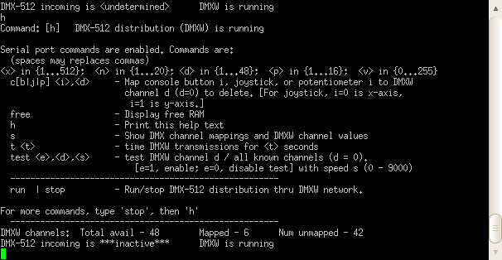
- Enter h to get a list of commands available in the current DMXW distribution mode. When the gateway is first powered on, the default distribution mode is running and the help screen appears as in the figure below. (In this distribution mode, you will notice that the DMXW Activity LED pulsates.) While DMXW channels are being broadcast, there is a limited number of commands available as most commands interfere with the channel data transmission timing.

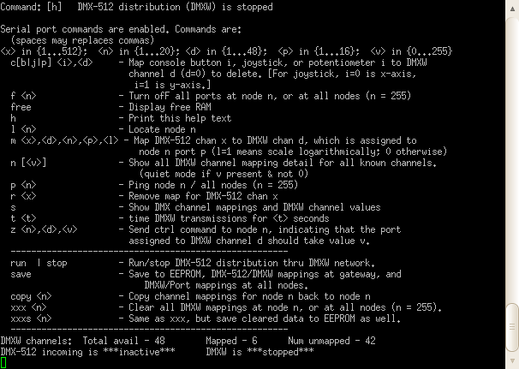
If you enter the stop command, the mode will switch to DMXW distribution stopped and the DMXW Activity LED will turn off. When you enter h again, the help screen will appear as in the figure below. Entering run will cause the gateway distribution mode to switch back to running. During configuration, most of the commands will be entered while DMXW distribution is stopped.

Configuring the DMXW Gateway
Whether you choose to use the DMXW Gateway as a standalone controller or for wireless redistribution of DMX-512 channels, you will need to configure mappings from DMX-512 channels to DMXW channels and DMXW channels to output ports on DMXW nodes.
Figure 6 illustrates how DMX-512 channels can map to DMXW channels which then map to output ports at various DMXW remote nodes. The DMXW Gateway ultimately provides the mappings from DMX-512 channels to the remote nodes' output ports. Using the configuration terminal, from 1 – 48 DMX-512 channels are each arbitrarily mapped to a unique DMXW channel and each DMXW channel is mapped to a DMXW remote node number and one of that node's port numbers. As an example from the figure, DMX-512 channel #505 could be mapped to DMXW channel #6, which is mapped to port #15 on DMXW Node #2, which in turn may be connected to a motor.

Entering Configuration Terminal Commands
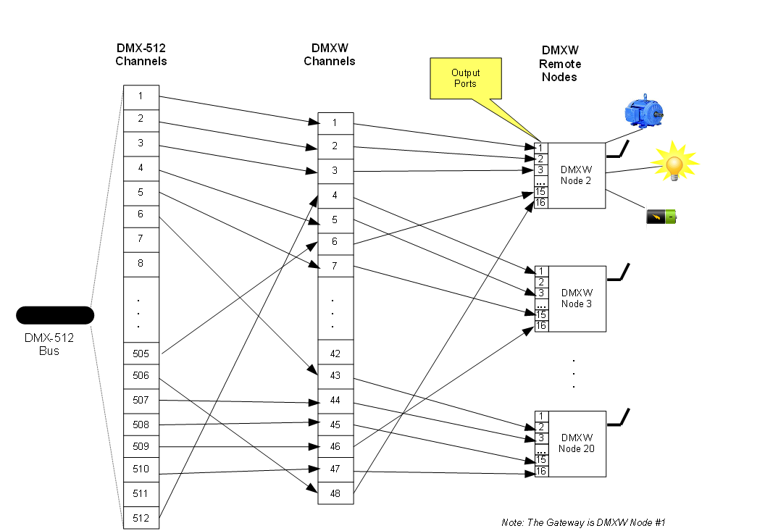Figure 6: DMXW Channel Mapping
Configuration terminal commands use a loose syntax: it is not necessary to have a space immediately following the command name; and, command parameters may be separated by either commas or spaces and extra spaces between parameters are ignored. For example, the channel mapping command (m) has the following stated syntax:
m <x>,<d>,<n>,<p>,<l>
The following entered commands would be equivalent:
m 505,6,2,15,0
m505 6 2 15 0
m 505, 6 2,15 0
The examples in this section use the first form.

Disabling the Configuration Terminal
At times it may be convenient to leave the configuration terminal connected to the DMXW Gateway while the DMXW distribution is running. Yet, you may wish to safeguard against commands—and their potentially negative consequences—being activated accidentally at the terminal. To provide this measure of safety, slide the Config Enable switch to the “Disable” position. A short informational message will appear at the terminal and no commands will be accepted until the switch is moved back to the “Enable” position.

About DMX Distribution Modes
When the DMXW Gateway is first powered on, DMXW distribution will start actively running. The gateway DMXW distribution is said to be in running mode. While in this mode the DMXW Activity LED pulsates and the configuration terminal help screen (enter the h command) will reflect this as shown at the bottom right of Figure 7.
By entering the stop command in the configuration terminal, DMXW distribution will stop. The gateway DMXW distribution is then said to be in the stopped mode. While in this mode the DMXW Activity LED will remain off and the configuration terminal help screen will reflect the new mode as shown at the bottom right of Figure 8. Entering the run command will start DMXW distribution running again.
A number of configuration terminal commands interfere with DMXW distribution. So fewer commands are available while DMXW distribution is running. One additional command, test, is only available in running mode since it runs a test of all DMXW channels that are mapped at the gateway.

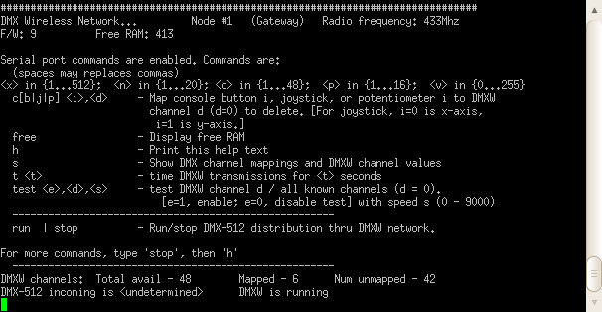Figure 7: Configuration Terminal Help Display While DMXW Distribution is in "Running" Mode
Figure 8: Configuration Terminal Help Screen while DMXW Distribution is in "Stopped" Mode

Mapping DMX-512 Channels to DMXW Channels
- At any time, enter h for help with configuration terminal commands, to see the current DMX-512 activity and DMXW distribution status, and see a summary of the number of DMXW channels that have been mapped and remain available.
- Enter stop at the configuration terminal to ensure DMXW distribution is stopped.
- To map DMX-512 channel #505 to DMXW channel #6 which is to get distributed to port #15 at DMXW remote node #2 (see Figure 6), enter the following command:
m 505, 6, 2, 15, 0
- If port 15 is a digital output (on/off) port, the “0” in the command is fine. However, if the port is an analog output port (responding in some proportion to channel data values 0 – 255), you need to determine whether the device connected to that port has a linear or logarithmic response to the channel data values. For example, people perceive a doubling of light output as less than double; it's perceived as a logarithmic increase relative to actual output. If an uncompensated light source is connected to an output port, then using the previous example, enter the following command:
m 505, 6, 2, 15, 1
In this way, output port 15 will have a logarithmic response to the data values piped thru DMX-512 channel #505. It will also have a logarithmic response to a console control potentiometer or joystick axis if one is mapped to DMXW channel #6.
- If a light source connected to port 15 is compensated (such that a change in channel data value from, say, 10 – 20, is perceived as a doubling of light intensity), then the command in step (3) is more appropriate.
- To confirm the current set of mappings, enter s to show the complete list of mappings, including which (if any) console controls are mapped to DMXW channels (refer to section 3.5 Mapping Console Controls to DMXW Channels).
- Repeat steps (3) thru (6) as desired.
- If it is necessary to remove individual mappings, enter:
r <DMX-512 channel #>

Mapping Console Controls to DMXW Channels
- At any time, enter h for help with configuration terminal commands, to see the current DMX-512 activity and DMXW distribution status, and see a summary of the number of DMXW channels that have been mapped and remain available.
- Console controls can be mapped to DMXW channels while DMXW distribution is either stopped or running.
- The syntax for mapping a console control is:
c<b | j | p> <i>,<d>
where: <i> is the control # and <d> (in the range 1 – 48) is the DMXW channel # to which the control is to be mapped (or 0 to remove the mapping).
There should be no space between c and the next character.
There are a total of 9 individual console controls that can be mapped to any DMXW channel.
There are 5 on/off buttons or switches: buttons (switches) 1 – 4 are toggle switches; and, button 5 is the momentary contact switch located on the joystick. To map one of these, enter:
cb <i>,<d>
where: <i> is in the range 1 – 5
There are 2 potentiometers. To map one of these, enter:
cp <i>,<d>
where: <i> is 1 or 2
There are 2 joystick axes (each equivalent to a spring-loaded potentiometer). To map one of these, enter:
cj <i>,<d>
where: <i> is 0 (for the left-to-right X axis) or 1 (for the up-to-down Y axis)
- As an example, to map the joystick Y axis to DMXW channel #6 (DMX-512 channel #505 from the example in the previous section), enter:
cj 1,6
- To confirm the mapping, enter:
s
- Repeat steps (3) - (5) as desired.
- Be careful not to map more than one control to the same DMXW channel. The behaviour of the controls will be unpredictable. You can execute the next step if you need to remove a mapping.
- To remove a mapping, use the c command with a “0” for the DMXW channel #. For example, to remove the mapping that was added in step (4), enter:
cj 1,0

Saving and Clearing Configuration Data
Changes to DMX-512 and console control mappings are lost if the DMXW Gateway or a remote DMXW node loses power unless the changes are saved. While DMXW distribution is stopped, channel mapping changes can be saved by entering the following command at the configuration terminal:
save
This will cause the gateway and all mapped remote nodes to save their mappings so that they will survive power losses.
Channel mappings for a node can be wiped out by entering one of the following commands:
xxx <DMXW remote node #>
- This will clear all channel mappings for the specified remote node, both at the node and at the gateway. The change, however, is not saved; if the node or gateway power is toggled off and on, the mappings will reappear and there may be a mapping inconsistency between the node and gateway. As long as there are no mappings defined at the node, a save command will save the changes at the gateway, but not at the node. If you wish to clear the node's mappings and have the change saved at the node, use the xxxs command. If you wish to clear the node's mappings but add at least one new mapping, a subsequent save will cause the new mapping to be saved at the node (and, of course, at the gateway).
xxx 255
- This will clear the mapping for all remote nodes, both at the nodes and at the gateway. Again, the changes are not saved and mapping inconsistencies could occur if a device loses power. The same cautions as above apply regarding subsequent save commands.
xxxs <DMXW remote node #>
- This will both clear all channel mappings for the specified remote node (both at the node and at the gateway) and save those changes (at both the node and gateway).
xxxs 255
- This will clear all channel mappings for all remote nodes and save the changes, both at the nodes and at the gateway.

Copying Channel Mappings from Gateway to Remote Node
In the event that the channel mappings at a remote node become inconsistent with the gateway, you can either clear all of the mappings or copy back the mappings that are known by the gateway back to the remote node. If you have multiple remote nodes that have the same node #, this mechanism can be used to clone the node. To copy the channel mappings for a node, enter the following command:
copy <n>
where: <n> is the node # (in the range 2 – 20)
To make the changes permanent, save the changes by entering:
save

Miscellaneous Commands
l <n> where: <n> is a node # (in the range 2 – 20, or 255)
- Remote DMXW nodes typically have an LED intended for locating and distinguishing between multiple nodes. This command is only available while DMXW distribution is stopped. It will activate a visible indicator (usually a blinking LED) at the node until it is instructed to turn off (refer to the f command below).
- When <n> = 255, all nodes will blink. This can be useful for determining whether or not a node is recognized and properly programmed.
f <n> where: <n> is a node # (in the range 2 – 20, or 255)
- This command instructs the specified remote DMXW node (or all remote nodes) to turn off all of their output ports. It can be used to quiet down a located node, or to turn off outputs that have been, for whatever reason, left on.
p <n> where: <n> is a node # (in the range 2 – 20, or 255)
- This command “pings” a remote DMXW node (or all remote nodes), instructing it (them) to confirm its (their) presence on the DMXW wireless network.
- If you have cloned nodes on the network (i.e. multiple nodes with the same node #), they are unlikely to respond correctly.

n
- This command queries remote DMXW nodes to report their details on each DMXW channel mapping that is known to the DMXW Gateway. The gateway queries each individual channel mapping one at-a-time.
z <n>,<d>,<v>
where: <n> is a node # (in the range 2 – 20)
<d> is a DMXW channel # (in the range 1 – 48)
<v> is a DMX-512 data value (in the range 0 – 255)
- This command instructs node # <n> to set the value of the output port that's mapped to DMXW channel # <d> to value <v>.
- This command can be used for testing a channel mapping without the need to use either the console controls or have an active DMX-512 bus feed.
test <e>,<d>,<s>
where: <e> is 1 (to start the test) or 0 (to abort the test)
<d> is a DMXW channel # (in the range 1 – 48) or
0 (to test all 48 DMXW channels)
<s> is a relative test speed control value (in the range 0 – 9000)
- This command runs a test sequence on the specified DMXW channel. It cycles thru the data values 0 – 255, repeating the cycle for 10 iterations (unless aborted).
- If <d> = 0, each of the 48 DMXW channels is tested in turn (from channel #1 thru to #48) during each of the 10 iterations.
- To abort the test, enter: test 0
- You may have to repeat the command two or three times before the test stops.
- This command can be used, for example, to quickly check that a node (or nodes) is powered up and operating correctly. It does not require the use of gateway console controls or an active DMX-512 bus feed.

Firmware Developer Commands
The following commands are typically only useful to firmware developers:
free
t <t>

Operating the DMXW Gateway
The DMX-512 Wireless Gateway (or DMXW Gateway) can be used in two main operating modes as dictated by the position of the Operating Mode switch on the gateway's front panel:
- Normal – the normal mode of operation (described in this section).
- Program – the mode used for upgrading the gateway's firmware (refer to section 6 Upgrading the DMXW Gateway Firmware).
While in normal operating mode, the gateway can be used in two ways:
- Standalone operation:
In this mode the DMXW Gateway need not be wired to a DMX-512 bus. Once appropriate channel mappings have been configured, console controls on the gateway have been mapped to DMXW channels, and the console controls enabled, the console controls on the gateway can be used for manual control of up to 9 output ports located on one or more remote DMXW nodes. When the gateway is running under battery power, this provides for a very mobile means of manual control. In this mode the Console switch on the gateway's top console panel should be set to the “Enable” position and the LED above the switch should be lit.
- DMX-512 redistribution operation:
In this mode the DMXW Gateway needs to be wired to a DMX-512 bus. Once appropriate channel mappings have been configured, a DMX-512 lighting desk can control up to 48 output ports located on one or more remote DMXW nodes. Console controls on the gateway may also be mapped to up to 9 DMXW channels and can enabled at any time for manual override of their corresponding DMX-512 channels. To enable manual override, the Console switch should be set to “Enable”. The LED above the switch is lit whenever the console controls are enabled for manual override.

Setting Up
- Before using the DMXW Gateway for normal operation, it must first be configured with at least one channel mapping from a DMX-512 channel to a DMXW channel to an output port on a remote DMXW node. Refer to section 3 Configuring the DMXW Gateway.
- If you will be using the DMXW Gateway for DMX-512 redistribution, ensure that the gateway is connected correctly to the DMX-512 bus. Refer to section 2.1 Connecting to a DMX-512 Bus.
- With the DMXW Gateway configured, ensure that the Operating Mode front panel switch is set to the “Normal” position.
- You may wish to keep a configuration terminal connected to the DMXW Gateway. If so, you may decide at any time to enable or disable terminal commands as described in section 3.2 Disabling the Configuration Terminal.
- Power up the DMXW Gateway. The DMXW Activity LED should start pulsating. If not, and a configuration terminal is connected, enter the run command to start DMXW distribution running.
- If you are redistributing DMX-512 channels, ensure that there is an active data feed coming from the DMX-512 data source (such as a lighting control console). Confirm the feed is active by noting that the DMX-512 Activity LED is pulsating.
- For standalone operation, or if manual control is otherwise desired, ensure that the Console switch is set to the “Enable” position; the LED above the switch will light up. Otherwise, ensure that it is set to the “Disable” position (and the LED will be off).
- It is a good idea to confirm that all DMX-512 channels and console controls are operating as expected prior to commencing normal operation.

Configuring and Programming Remote DMXW Receiver Nodes
A DMXW remote wireless receiver node can use any underlying computer platform chosen by its designer. It only needs to ensure that it uses an RFM68W 433 MHz radio and that it conforms to the DMXW protocol. This section only applies to DMXW remote wireless receiver nodes that are implemented using one of the Moteino micro-controller boards (http://www.lowpowerlab.com/shop).
To configure or program a Moteino based remote DMXW node, you will need:
- The Arduino IDE (as is used for upgrading the DMXW Gateway firmware)
- If the underlying Moteino board, or the node on whole, lacks a built-in USB port, a USB-to-FTDI adaptor is needed.
To program a Moteino based remote DMXW node, you will also need a copy of the freely available “DMXW Node” Arduino source code.
Connecting to the node will depend on whether or not the board has a built-in USB port (requiring a USB-to-FTDI adaptor versus requiring just a mini USB cable between node and computer). Once connected, however, the programming steps are the same.
Programming (or upgrading the firmware of) a remote DMXW node involves the same process as for the gateway. (Refer to section 6 Upgrading the DMXW Gateway Firmware.) When modifying the firmware, it is recommended that you increment the firmware version number. This will ensure that the device erases configuration data (such as the DMXW channel mappings) from its EEPROM the next time it is powered up. This is especially important if the structure of the data stored in EEPROM is changed.
Configuring a Moteino based DMXW node can be done using either terminal emulator software (such as PuTTY) or directly within the Arduino IDE by opening the IDE's Serial Monitor while connected to the node. The icon for the monitor is located near the top right of the IDE window. When you click on the icon, the DMXW node is reset and an IDE terminal window opens. Once connected, you should see a banner followed by some help text. The banner identifies the Moteino as a DMXW node running at 433 MHz, the firmware version number, and the DMXW node number (Node ID). If you need to modify the node number, enter the following command in the command line at the top of the monitor window:
nodeid <new node number>
where: <new node number> is in the range 2 – 20
You should ensure that all remote DMXW nodes are uniquely numbered unless you plan on cloning nodes. If you do plan to clone nodes, ensure that every node with the same node number has the same data copied to it. (Refer to the copy command in section 3.7 Copying Channel Mappings from Gateway to Remote Node.)
The other command you will likely want to use at some point is the s (show) command that lists information about DMXW channel mappings as known to the node.

Powering a Remote DMXW Receiver Node
A DMXW Receiver Node is typically connected to, and controls, devices that have large electrical power needs relative to the Moteino. The Moteino can be fed with 3.3 – 12 Vdc and, itself, uses very little power; it can actually run on coin cell batteries for months. In order to protect the sensitive Moteino board, it is recommended that careful thought be applied to ensure that any Moteino input or output port which connects to logic, switching, or amplifying circuity running at higher voltages is electrically isolated from the Moteino ports—e.g. using opto-isolators. If the Moteino directly controls an electo-mechanical relay, ensure that a diode is placed across the relay's energizing coil, as a very large reverse voltage spike is possible when a relay is de-energized. In cases where 120 Vac mains power is needed for the controlled devices, it is strongly recommended that you: (1) find help from a qualified person; and, (2) install electrical isolation mechanisms between the mains power circuitry and the low voltage circuitry.

Upgrading the DMXW Gateway Firmware
The DMXW Gateway's firmware can be updated by powering it on and setting the Operating Mode switch to the “Program” position. You will need to have:
- a computer that is running the freely available Arduino Integrated Development Environment (IDE)
- a USB-to-FTDI connector, and
- the DMXW Gateway source code
The gateway uses the equivalent of an Arduino UNO board. Go to the Arduino web site (http://www.arduino.cc) to acquire the IDE and for instructions on programming an Arduino board.

In the Arduino IDE, be sure to set Tools > Board > Arduino Uno

Each DMX-512 channel consists of a stream of data, each data value in the range 0 – 255 (inclusive).
A remote receiver node could, however, use 120 Vac mains power for, e.g., situations where DMX-512 is awkward or prohibitve while mains power is accessible and needed for the device(s) being controlled.
It is possible to clone nodes, thereby increasing the total number of DMXW remote nodes. A cloned node will share the remote DMXW node number and channel mapping configuration.
The gateway and remote nodes communicate using a simple bidirectional protocol—the DMX Wireless (DMXW) protocol.
In the future, this command will likely be split into multiple commands for mapping DMX-512 channel numbers to DMXW channel numbers, and for mapping DMXW channel numbers to node number, port number pairs. This will allow the DMXW channels to be configured prior to having determined which DMX-512 channels are to be used. It will also allow DMXW channels to be reassigned to different DMX-512 channels without requiring full knowledge of the node and port numbers—with, say, function or role names assigned to the DMXW channels.
This is only because there is a bug in the code. (To be corrected.)
These are to be removed from the regular menu. TBD: create a separate debug help command.

